**Lab Practical #02:**

Study of different types of network cables & connectors and practically implement the cross-wired cable and straight through cable using clamping tool.

**Practical Assignment #02:**

1. List various networks cable and connectors. Also, write short description.
2. Give cross-wired cable and straight through cable diagram (Color Code wise).

## List various networks cable and connectors. Also, write short description.

1. **Network Cable Name: Coaxial Cable (RG-6/RG-59)**
   * **Network Cable Type:** Guided
   * **Description**: A coaxial cable is an electrical cable with a copper conductor and an insulator shielding around it and a braided metal mesh that prevents signal interference and cross talk. Coaxial cable is also known as **coax.**
   * Coaxial cables are commonly used for cable TV and broadband internet connections. They have a central conductor surrounded by insulation, a metallic shield, and an outer protective layer.
   * **Diagram**:

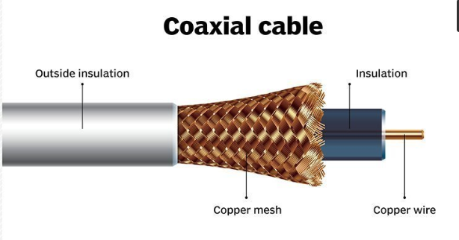

**RG6 Coaxial Cable**

**Diameter**: RG6 cables have a diameter of approximately 0.27 inches (6.86 mm).

Frequency Range: They support frequencies up to 3 GHz, suitable for most home applications.

**Attenuation**:RG6 cables have higher attenuation, meaning they lose signal strength more quickly over long distances.

**Applications**: These cables are commonly used for home internet and cable TV installations.

**Center Conductor**: Typically, RG6 cables use a copper-clad steel center conductor.

**Shielding**: RG6 cables can have single or dual-layer shielding.

**Flexibility**:They are more flexible and easier to install, especially in tight spaces.

**Cost**:RG6 cables are generally less expensive compared to RG11 cables.

**Max Distance**:RG6 cables are effective over shorter distances compared to RG11.

**RG11 Coaxial Cable**

**Diameter**:RG11 cables have a larger diameter of approximately 0.40 inches (10.29 mm).

**Frequency Range**:Like RG6, RG11 cables support frequencies up to 3 GHz.

**Attenuation**:RG11 cables have lower attenuation, meaning they maintain signal quality over longer distances.

**Applications**:RG11 cables are used for long-distance cable runs and professional applications where signal quality is critical.

**Center** **Conductor**:RG11 cables typically use a solid copper center conductor for better conductivity.

**Shielding**: RG11 cables are usually quad-shielded, offering superior protection against interference.

**Flexibility**:RG11 cables are less flexible and more rigid, making them harder to install in tight spaces.

**Cost**: RG11 cables are more expensive due to their enhanced performance and materials.

**Max Distance**:RG11 cables can effectively carry signals over longer distances than RG6 cables.

1. **Network Cable Name: USB Cable (Universal Serial Bus)**
   * **Network Cable Type:** Unguided
   * **Description**: The term USB stands for "Universal Serial Bus". USB cable assemblies are some of the most popular cable types available, used mostly to connect computers to peripheral devices such as cameras, camcorders, printers, scanners, and more.
   * USB cables are primarily used for connecting peripheral devices, such as printers, keyboards, and external storage devices, to computers. They also support networking through USB-to-Ethernet adapters.
   * **Diagram**:

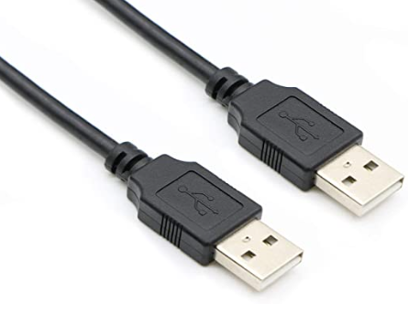

1. **Network Cable Name: Fiber Optic Cable**
   * **Network Cable Type:** Guided
   * **Description**: A fiber-optic cable contains anywhere from a few to hundreds of optical fibers within a plastic casing. Also known as optic cables or optical fiber cables, they transfer data signals in the form of light and travel hundreds of miles significantly faster than those used in traditional electrical cables.
   * **Diagram**:

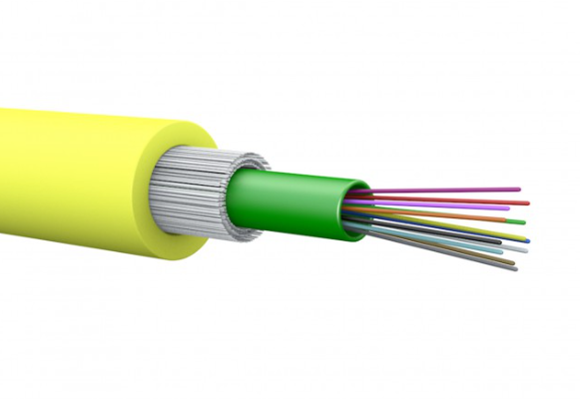

1.**Multimode**:-

Multimode fibre can carry multiple light rays (modes) at the same time by having varying optical properties at the core; essentially light travelling the shortest path (down the middle) travels the slowest.The larger core simplifies connections and takes advantage of the lower cost LED & VCSEL technologies which operate in the 850nm window. Due to dispersion the range is limited so it tends to be used as premises cabling when less than a kilometre. It comes in two core sizes, 62.5 and 50 microns.

2. **Singlemode**:-

Singlemode fibre has a much smaller core size of 9 microns and has a single light path and can travel much longer distances of up to 100km. These require more expensive electronics which operate in the 1310 and 1550nm windows and are typically used in longer distance LAN’s, Cable TV and telephony applications.

1. **Network Cable Name: Twisted Pair Cable**
   * **Network Cable Type:** Guided
   * **Description**: Twisted pair cable is a type of network cable that consists of pairs of insulated copper wires twisted together in a specific pattern. It is widely used in Ethernet networks for transmitting data signals.
   * **Diagram**:

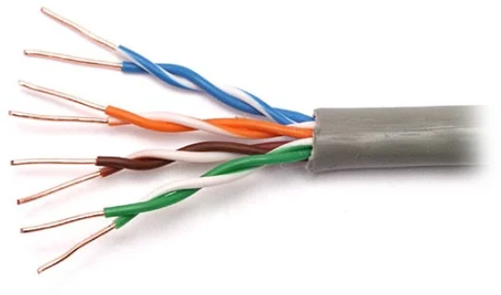

**Twisted Pair Cables are further of two types :**

1. **Unshielded Twisted Pair Cables (UTP) :**

* **Description:**These are a pair of two insulated copper wires twisted together without any other insulation or shielding and hence are called unshielded twisted pair cables. They reduce the external interference due to the presence of insulation. Unshielded twisted pair cables are arranged in pairs so that we can add a new connection whenever required. The DSL or telephone lines in our houses have one extra pair in them.

1. **Shielded Twisted Pair Cables (STP) :**

* **Description:**These types of cables have extra insulation or protective covering over the conductors in the form of a copper braid covering. This covering provides strength to the overall structure of the cable. It also reduces noise and signal interference in the cable.

**Difference:**

|  |  |
| --- | --- |
| Shielded Cable | Unshielded Cable |
| Expensive | Less costly compared to shielded cable |
| Less flexible | Flexible |
| Bigger in dia than unshielded | Diameter less than shielded |
| No technical issues including EMI | EMI may cause problem |
| Suitable for high-traffic networks | Not advisable for networks with increased traffic |
| Ideal for bigger firms | Suitable for offices and offices with fewer traffic with large network area |

1. **Network Cable Name: HDMI Cable (High-Definition Multimedia Interface)**
   * **Network Cable Type:** Unguided
   * **Description:** HDMI cables are used to transmit audio and video signals between devices, such as computers, game consoles, Blu-ray players, and TVs. They support high-definition video and multi-channel audio.
   * **Diagram**:

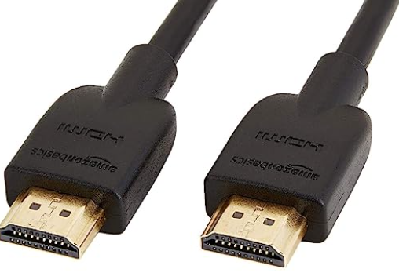

1. **Network Cable Name: DisplayPort Cable:**
   * **Network Cable Type:** Unguided
   * **Description**: DisplayPort cables are commonly used to connect computers and displays, such as monitors and projectors. They support high-definition video and audio signals.
   * **Diagram**:

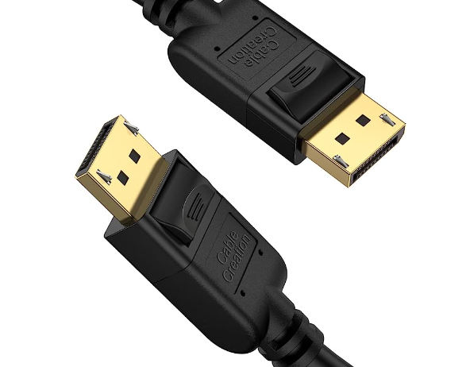

1. **Network Cable Name: Thunderbolt Cable**
   * **Network Cable Type:** Unguided
   * **Description**: Thunderbolt cables provide high-speed data transfer and video output capabilities. They are commonly used for connecting external devices, such as storage drives and displays, to computers.
   * **Diagram**:

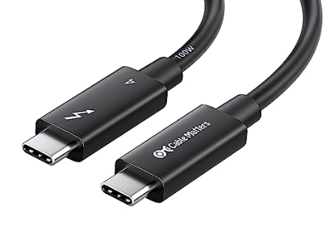

1. **Network Cable Name: T Type Connecter**
   * **Network Cable Type:** Unguided
   * **Description**: A fiber-optic cable contains anywhere from a few to hundreds of optical fibers within a plastic casing. Also known as optic cables or optical fiber cables, they transfer data signals in the form of light and travel hundreds of miles significantly faster than those used in traditional electrical cables
   * **Diagram**:

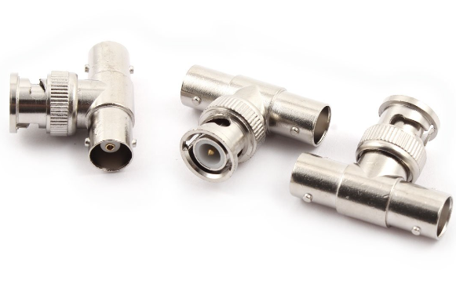

1. **Network Cable Name: RJ-45 connecter**
   * **Network Cable Type:** Guided
   * **Description**: A fiber-optic cable contains anywhere from a few to hundreds of optical fibers within a plastic casing. Also known as optic cables or optical fiber cables, they transfer data signals in the form of light and travel hundreds of miles significantly faster than those used in traditional electrical cables
   * **Diagram**:

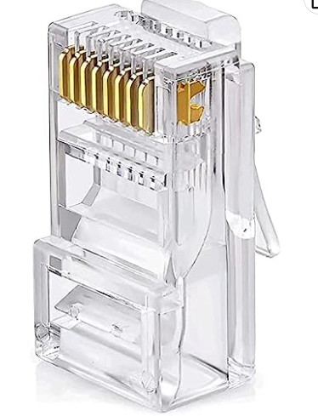

## Give cross-wired cable and straight through cable diagram (Color Code wise).

1. Cross-wired Cable Diagram (Color Code)

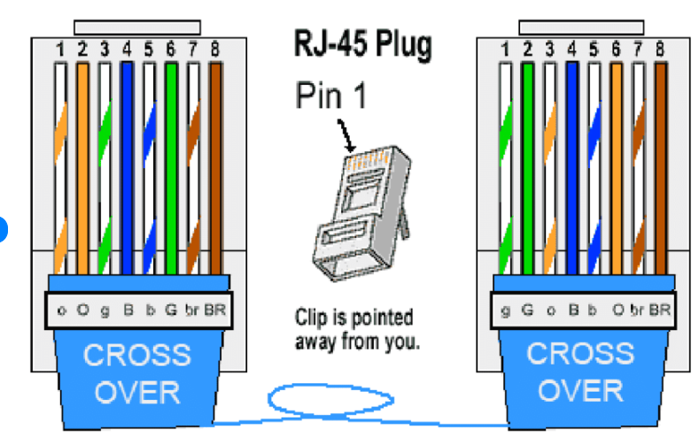

1. Straight Through Cable Diagram (Color Code)

